

FT60 Training Computer
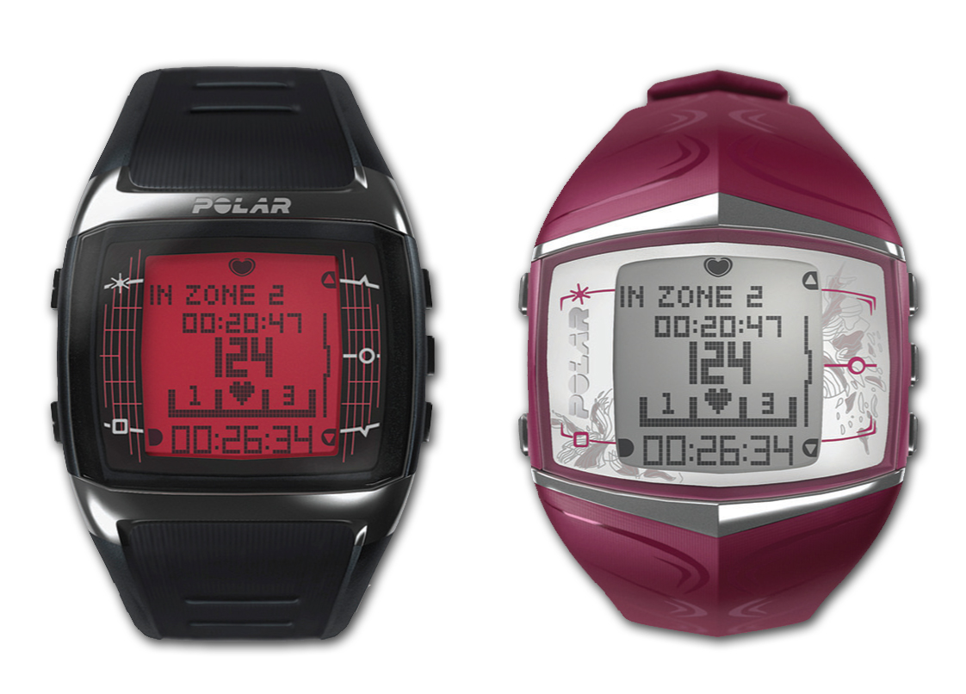

- Includes – wrist unit, Polar WearLink™ + transmitter
- MSRP (approx.) - $239.95
- Available –
  - Four versions – men’s (black w/ red screen, black w/ white screen), women’s (red and black)
  - To purchase online – www.polarusa.com/store
  - To purchase at retail and specialty shops - http://polarusa.com/findstore/stores_con.asp

FT60 Overview
- Helps improve fitness and keeps users motivated with the new Polar STAR training program, which adapts to the user’s personal exercise habits, providing weekly feedback and updated goals
- Synchs with G1 GPS sensor and S1 Foot Pod™ for those who want to begin tracking speed and distance
- Designed for fitness enthusiasts, gym goers, runners and active sport participants
- Stylish watch that can be worn any time, at work or play
- Synchs with www.PolarPersonalTrainer.com, an online exercise journal and community that provides guidance, tracks progress and goals and allows users to challenge their friends

Features
- Polar STAR training program (see above)
- Polar Fitness Test – finds your baseline fitness level in just five minutes; predicts VO2max
- Show calories burned, duration and time spent in each zone – light, moderate or hard (see picture above)
- Zone lock – enables training to a specific intensity
- Stores 100 workout files and 16 weekly training summaries

Accessories
- Polar FlowLink™ – the new, exclusive data transfer unit – makes it quick and incredibly easy to transfer training data from the watch to www.PolarPersonalTrainer.com. Simply set the watch face down on the FlowLink, which connects through a USB port, and the data transfer process automatically begins.
- New G1 GPS Sensor – provides speed / distance measurement for outdoors sports
- S1 Foot Pod™ – measures speed, pace and distance for indoor / outdoor running

# # #

