

For Immediate Release

Contact: Hilary Hutcheson, PR Director

hilary@outsidemedia.com (503) 828-7074

Suunto Updates Training Series of Heart Rate Monitors
The Dual Comfort Belt makes Suunto T-Series the ultimate multi-sports solution

Ogden, UT--March 2010--Suunto, a global leader in sports precision instruments, has added new features to its successful training line of heart rate monitors.
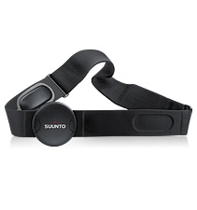
The new Dual Comfort Belt is the only heart rate chest strap on the market that combines the digital ANT-technology and analog transmission. This means users won't get disturbance as they choose to train alone, with a group, or connect with gym cardio equipment. The Dual Comfort Belt is also compatible with all Suunto PODs for monitoring speed and distance. The Dual Comfort Belt is light weight, sleek, and made comfortable, hand-washable textile material. Batteries are user-changeable.

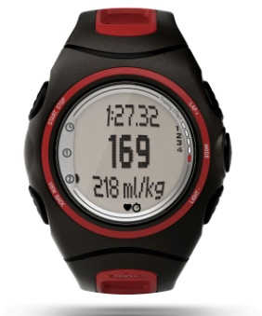
Suunto refreshed the design of is training line of heart rate monitors. The new t6d Black Fusion and t6d Black Smoke are now available in black, with stylish red and grey accents. The Suunto t6d is targeted for committed amateur and professional athletes. It measures the time interval between heart beats and its variations to produce seven different body parameters. The Suunto t6d features Training Effect, EPOC (Excess Post-Exercise Oxygen Consumption), and calories burned. It's compatible with the Suunto Foot POD, Bike POD, GPS POD and Cadence POD.
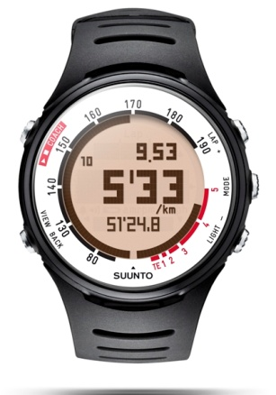
Suunto t4d White Blaze and Suunto t4d Silver Frost feature the Suunto Coach function, helping users maximize their performance. The Suunto Coach feature generates a personalized five-day training plan that helps to maintain a balance between workout and rest times. It makes intelligent recommendations for the frequency, duration, and intensity of workouts and gives accurate, personalized guidance by prescribing different training intensities on different days. Using Training Effect as a guide, Suunto Coach maps out an accurate schedule of when to train and when to rest - and adapts the program according to the actual days users train.

Suunto t3d Black, Suunto t3d Black Polished and Suunto t3d Sporty Red allow users to track their progress with real time Training Effect: a quick and accurate measurement of how hard their body's working at any given moment.

Suunto is a leading designer and manufacturer of sports precision instruments for training, diving and outdoor sports. Prized for their design, accuracy and dependability, Suunto wristop computers combine the aesthetics and functionality of watches with sport-specific computers. Headquartered in Vantaa, Finland, Suunto employs more than 500 people worldwide and distributes its products to more than 100 countries. The company is a subsidiary of Helsinki-based Amer Sports Corporation with sister brands Wilson, Atomic, Precor, Salomon, Mavic and Arc’teryx. www.suunto.com www.twitter.com/suuntousa

